**Problem Statement** : Insert an element at the beginning of an linked list using Python

**Objective :** Implementation of Inserting an element at the beginning of an linked list using Python

**Source Code :**

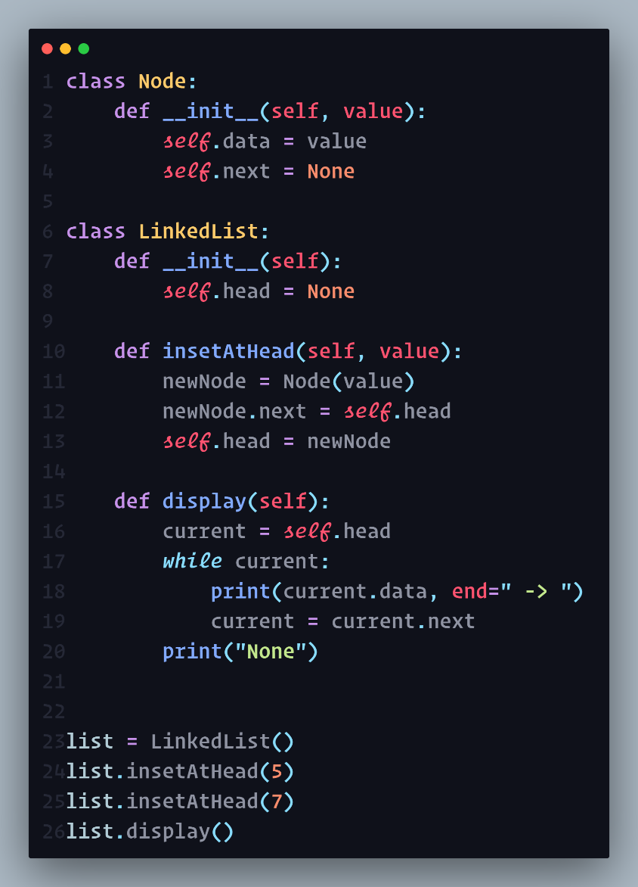

**Output :**

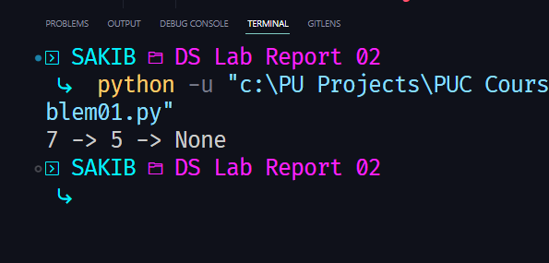

**Problem Statement** : Insert an element at the end of an linked list using Python

**Objective :** Implementation of Inserting an element at the end of an linked list using Python

**Source Code :**

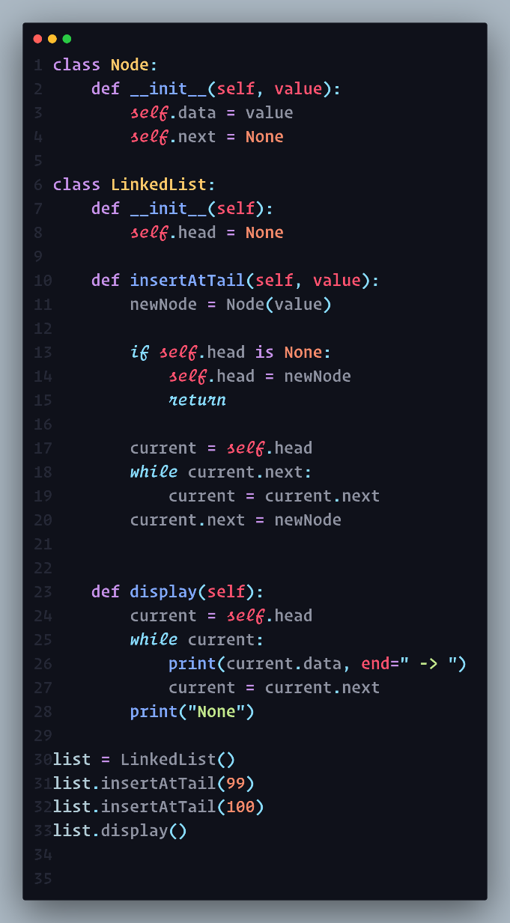

**Output :**

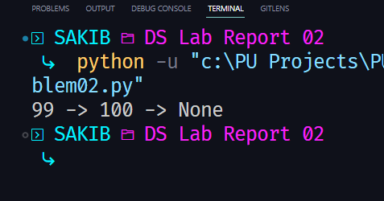

**Problem Statement** : Insert an element between nodes using Python

**Objective :** Implementation of Inserting an element between nodes of an linked list using Python

**Source Code :**

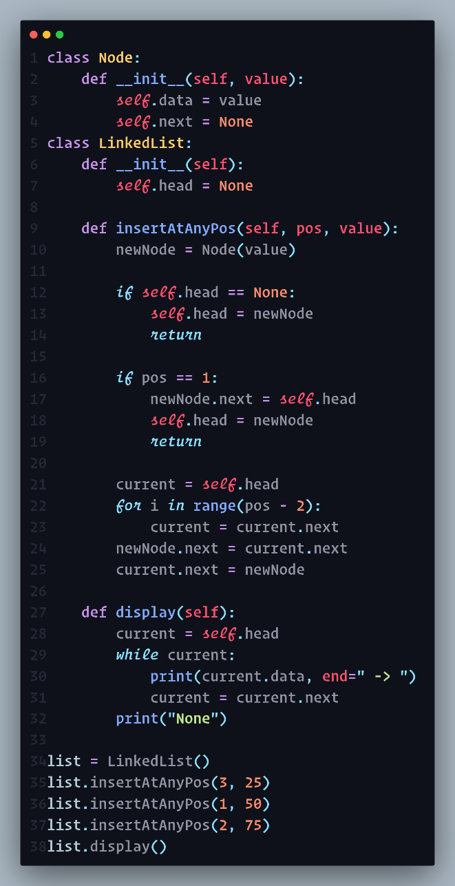

**Output :**

